**Experiment No. 02**

**1. Problem Statement:** The probability density function of the signal-to-noise ratio of Rayleigh Fading SIMO is given by

$$f_{γ}\left(γ\right)=\frac{1}{\overline{γ}}exp\left(\frac{γ}{\overline{γ}}\right) , γ>0$$

**(a) Derive the expressions of** the outage probability of Rayleigh fading SIMO channel.

**(b) Write the programs of** the outage probability of Rayleigh fading SIMO channel.

(**c) Explain the numerical results of** the outage probability of Rayleigh fading SIMO channel.

**2. Derivation of outage probability (CDF) of Rayleigh fading SIMO channel**

Let,

$γ∑$**=** Signal to noise ratio (SNR)of Combiner output

$γ_{i}$**=** SNR of each branch (i = 1; 2; ∶∶∶; $n_{R}$)

$n_{r}$**=** Number of Antennas at the Receiver

$γ_{th}$**=** Threshold SNR

Probability Density Function (PDF) of $γ_{i}$-

$$f_{γ_{i}}\left(γ_{i}\right)=\frac{1}{\overline{γ_{i}}}exp\left(-\frac{γ_{i}}{\overline{γ_{i}}}\right)$$

Where, $\overline{γ_{i}}= E[γ_{i}]$

Probability Density Function (PDF) of $γ_{th}$-

$$f_{γ_{th}}\left(γ_{th}\right)=\frac{1}{\overline{γ_{i}}}exp\left(-\frac{γ_{th}}{\overline{γ_{i}}}\right)$$

Cumulative Distribution Function (CDF) of $γ_{th}$-

$$F_{γ_{i}}\left(γ_{th}\right)=\operatorname{Pr}\left(γ_{i}<γ_{th}\right)=\int_{0}^{γ_{th}}{\frac{1}{\overline{γ_{i}}}e^{\left(-\frac{γ_{th}}{\overline{γ_{i}}}\right)} dγ_{th}}$$

Cumulative Distribution Function (CDF) of $γ∑$ at $γ_{th}$-

$$F_{γ_{i}}\left(γ_{th}\right)=\operatorname{Pr}\left(γ∑<γ_{th}\right)$$

$= \operatorname{Pr}{\{max\left(γ_{1}, γ_{2}, γ_{3}……, γ_{nr}\right)}$

$=\prod_{i=1}^{n_{R}}{\operatorname{Pr}\left(γ_{i}<γ_{th}\right)}$

$=\prod_{i=1}^{n_{R}}{F_{γ_{i}}\left(γ_{th}\right)}$

Outage Probability of $γ_{th}$-

$${ { P}_{out}\left(γ_{th}\right)=F}_{γ∑ }\left(γ_{th}\right)$$

**= $\prod_{i=1}^{n_{R}}{1-}e^{\left(-\frac{γ_{th}}{\overline{γ_{i}}}\right)}$**

**= ${(1-e^{\left(-\frac{γ_{th}}{\overline{γ_{i}}}\right)})}^{n_{R}}$**

This is the Outage Probability of Rayleigh Fading SIMO channel.

**3. Program for the outage probability of Rayleigh fading SIMO channel**

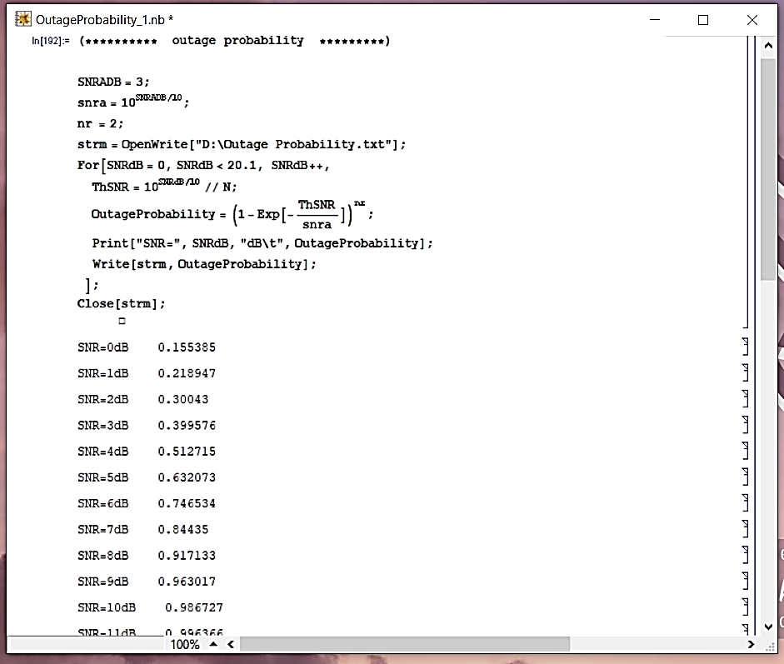

**4. Numerical results of the outage probability of Rayleigh fading SIMO channel for $n_{r}$ = 2**

**(a) Numerical data**



**(b) Graphical representation**

**Figure 2.1.** Outage probability vs Signal to Noise Ratio plot for Rayleigh fading SIMO channel.

**(c) Description of Figure 2.1:** This is a plot of the outage probability vs Signal to Noise Ratio for various values of the average SNR (SNRADB) for ***two*** Antennas at the Receiver. This graph depicts the impact of SNR on outage probability. The graph above demonstrates that as the SNR value increases, the outage probability rises. The rate at which the outage probability rises, is determined by the threshold SNR value.

**5. Numerical results of the outage probability of Rayleigh fading SIMO channel for $n_{r}$ = 4**

**(a) Numerical data**



**(b) Graphical representation**

**Figure 2.2.** Outage probability vs Signal to Noise Ratio plot for Rayleigh fading SIMO channel.

**(c) Description of Figure 2.2:** This is a plot of the outage probability vs Signal to Noise Ratio for various values of the average SNR (SNRADB) for ***four*** Antennas at the Receiver. This graph depicts the impact of SNR on outage probability. The graph above demonstrates that as the SNR value increases, the outage probability performance gets effected. Thus, system becomes more robust against fading, resulting in improved reliability.

**6. Discussion and Conclusion**

**a) Discussion:** The Outage Probability vs. Signal-to-Noise Ratio (SNR) plot for a Rayleigh fading Single-Input Multiple-Output (SIMO) channel gives useful information about the communication system's performance under fading conditions. The outage probability quantifies the likelihood that the instantaneous SNR may go below a specific threshold, resulting in a communication loss. Understanding this relationship aids in determining the communication system's dependability and robustness.

The received SNR at each antenna in a Rayleigh fading SIMO channel follows a Rayleigh distribution, which occurs from the superposition of several fading routes with equal power. As the SNR improves, the signal becomes more resistant to fading, resulting in a lower likelihood of outage.

**b) Conclusion:** From our investigation, we can draw the following conclusions:

* As the SNR rises, so does the likelihood of an outage. This is typical for communication systems since greater SNR values provide stronger received signals, lowering the risk of an outage. With increasing SNR, the curve frequently exhibits an exponential decrease.
* Here, SIMO systems benefit from diversity gain, which is the capacity to boost system performance by utilizing the spatial variety introduced by many antennas. The diversity gain grows as the number of receive antennas increases, resulting in a more significant reduction in outage probability at higher SNR values.
* Choosing the appropriate outage threshold (th) is critical in determining the desired level of reliability. A greater threshold suggests that the demand for dependable communication is stricter. As the barrier grows tighter, the likelihood of an outage increases.
* The number of reception antennas (SIMO configuration) has a significant impact on the shape of the curve. More antennas provide greater diversity gain, which improves outage performance at higher SNR values.

Finally, comprehending the statistical features of the Rayleigh-fading SIMO channel as revealed by the outage probability analyses is critical for building robust and efficient digital communication systems.